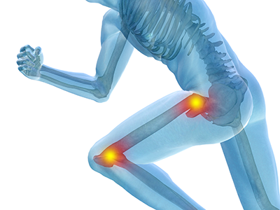
Total Knee & Hip Replacement
Joint Education Class

Location: Flagler Hospital
Where: 8th Floor Classroom
When: Every Monday and Wednesday
Time: 10:00 AM – 11:00 AM
Presenter: Sarah Adams, BSN, RN, Orthopedic Coordinator
Additional
Information: Please register online at flaglerhealth.org
under the Orthopedic Surgery page

A support person is encouraged to attend with you

